From this plot, the optimal fish growth weight of about 80 g was obtained with BSFL100 in 3 months. The optimal weight was predicted by the equation y = 67.79 + 10.32x – 1.41x2, where x represents FM substitution level.

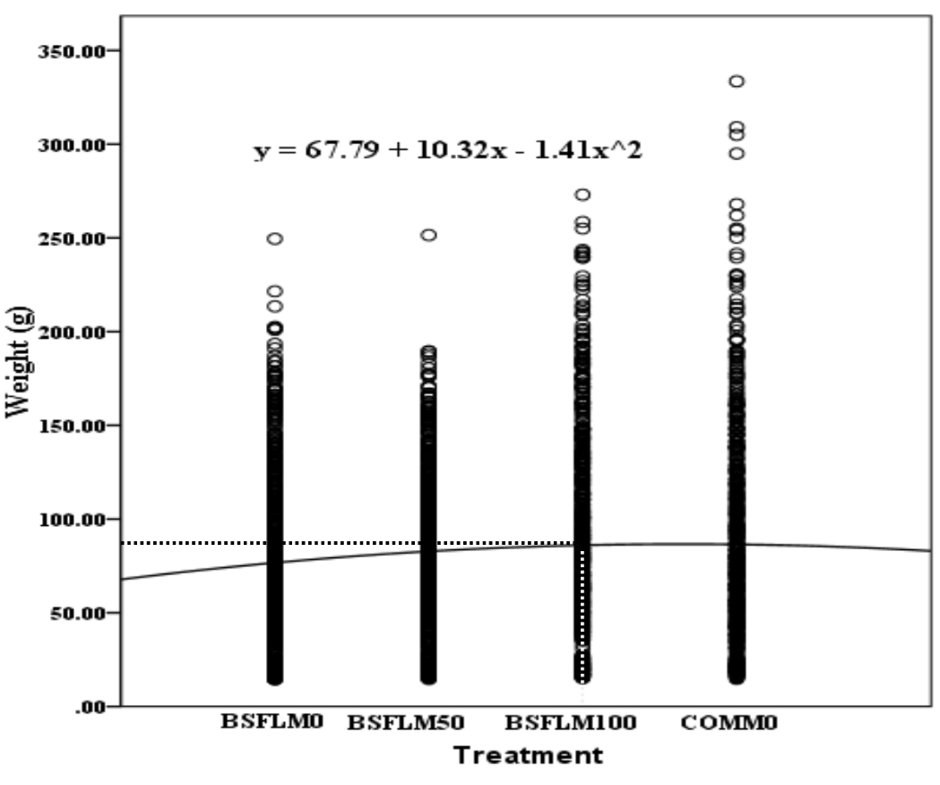

**Figure 1.** Polynomial regression growth curves for Nile tilapia fed with different concentration of the experimental diets. Comm0: Commercial diet; BSFL0, BSFL50, and BSFL100 represent substitution of fishmeal with 0 %, 50 %, and 100 % Black soldier fly meal, respectively. standard error of estimate: 49.414, Adjusted R2:0.005, F: 7.872, P = 0.000.